Name: Gaurang Vaghela
Rollno: BEAD-22561
DMV Practical 11
Problem Statement: Analyzing Sales Performance by Region in a Retail Company

1. Import the "Retail_Sales_Data.csv" dataset.
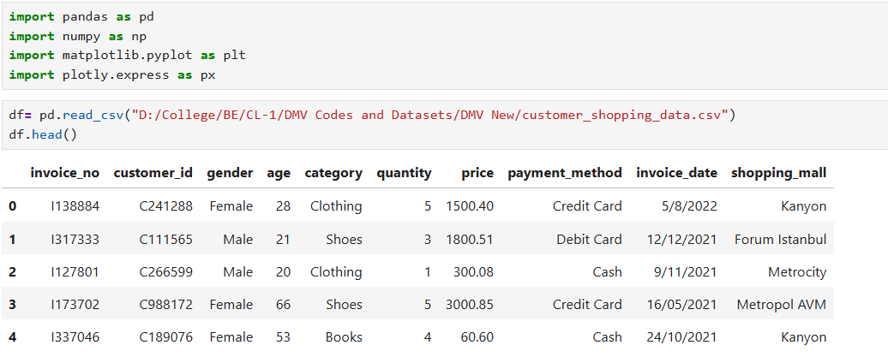
2. Explore the dataset to understand its structure and content.
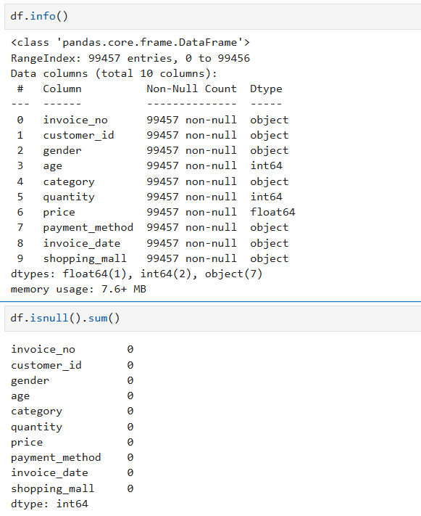

3. Group the sales data by region and calculate the total sales amount for each region.
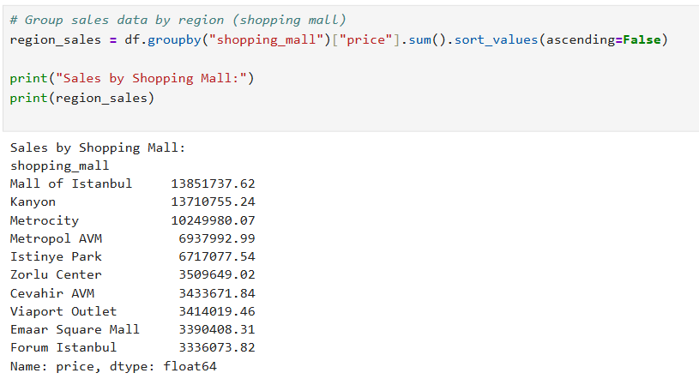
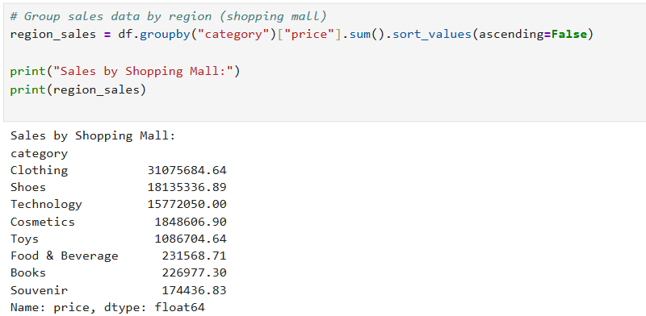

4. Create bar plots or pie charts to visualize the sales distribution by region.
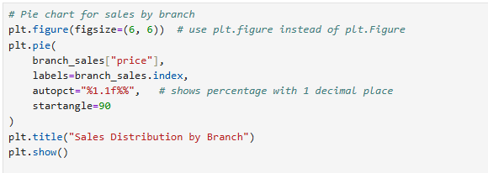
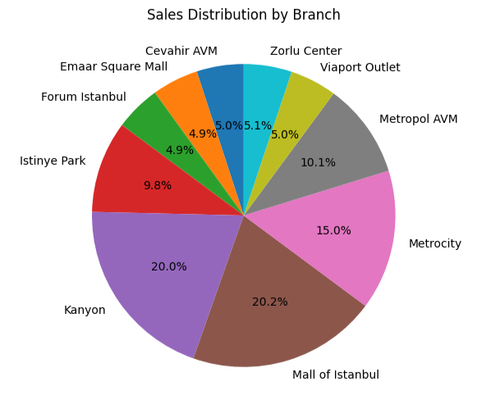

5. Create bar plots or pie charts to visualize the sales distribution by region.
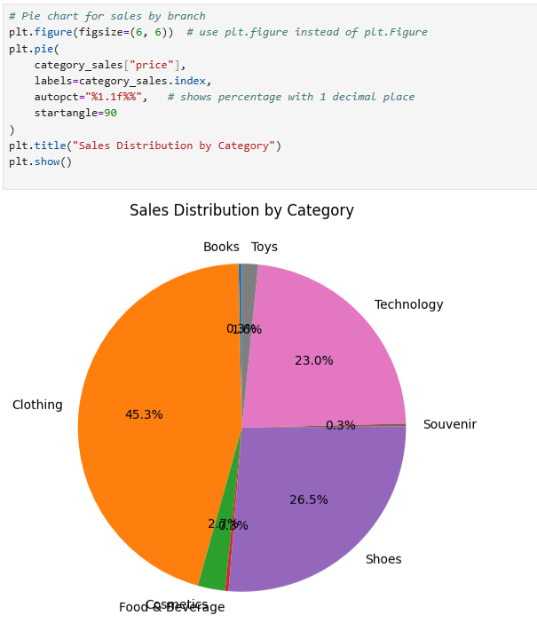

6. Create stacked bar plots or grouped bar plots to compare the sales amounts across different regions and product categories.
